Top Ten Toys for Kids with ASD (and how I use them)
Last year, I purchased the Discovery Toys starter kit, because I had used so many of their toys in the past, and they are fantastic for therapy and teaching. I didn’t want to sell the products; I just wanted $420 in toys for $140 and access to the consultant discount . Some were Christmas gifts, some were used in therapy and teaching, and some are in my own children’s playroom. Here are 10 of my favourite toys, and how I use them – not all are Discovery Toys – it’s my all-around favourite toys list.

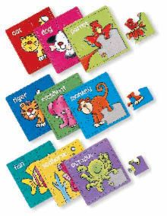
- Progressive Puzzles – these are great because they are step by step. There are simple-picture puzzles ranging from 4 to 9 pieces. I take it one step further and photocopy the puzzle onto cardstock, and place this inside the puzzle frame at first. You can then fade out the picture so the child next completes the puzzle without it (technically, he’s matching when that visual is included, not doing a puzzle), then later complete the puzzle without the frame at all. I use these as part of the ABLLS Visual Performance Domain.

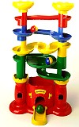
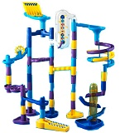
- Castle Marbleworks for early learners, and Marbleworks for older children. Great for problem solving, Marbleworks allows me to connect and expand communication skills while building the track (building on prepositions, turn taking, sharing, colours, shapes, following instructions, asking for help, and so many others). Plus, it allows me to use the marbles as reinforcers throughout the activity, and provides visual sensory reinforcement. While engaged in such a fun activity, it’s easy to slip in targets and maintain reinforcement throughout.

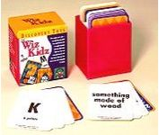
- Wiz Kids – great for working on feature/function/class. It’s a set of cards – half have a letter on them with a point value (like in scrabble), and the other has a category. You pull one of each, and see who can come up with something from the category starting with that letter. Ignore the letters to make it simpler if you choose, so simply coming up with something that is part of that category is the goal. Great travel game as it’s just a small card box, and scorekeeping is as simple as holding the cards with your points on them.

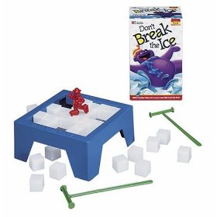
- Don’t Break the Ice – Not a DT toy, this one is available at your local toy or department store, and works as a great motivator. It’s fun and very easy to play (you take turns hammering plastic ice blocks out of a frame until the skating bear figure falls in). I begin the game setup, leaving maybe 10 blocks out. I hold onto the last 10 blocks, giving one to the child I’m working with for each response he provides, as a reinforcer (essentially a token system). When he has all the blocks, we can play the game together.

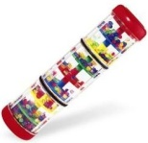
- Rainfall Rattle – simply put, the most popular sensory bin toy I’ve ever had. Small beads rain down through colourful disks, making the sounds of rain, and a visually stimulating show.

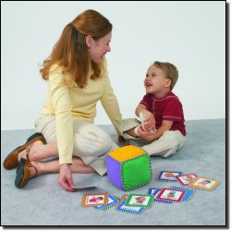
- Roll & Play – simple game where you roll the big stuffed die, pick up a card with a colour match to what you rolled, and act out what is says on the card. Great for building motor imitation skills, vocabulary, and following instructions.

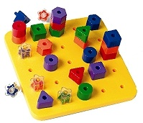
- Giant Pegboard – great for working on visual matching, imitation, sorting by shape and / or colour, patterning, and horizontal / vertical block design. Again, I love to build in reinforcement by ending with an activity to build the tallest tower we can, and crashing it over.

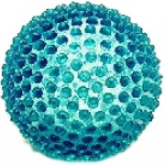
- Tangiball – another popular sensory bin toy, the Tangiball smells great (small smells like Vanilla, and big smells like strawberry). They squeak when squeezed gently, and have a nubby texture that’s great for tactile and proprioceptive input.

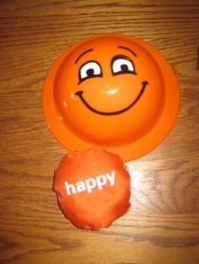
- Flip Flop Faces – one of the most fun ways to teach emotions I’ve ever seen. Cartoon facial expressions are printed on the outside of plastic bowl-shaped domes. Domes are placed open side up (face side down), and when a beanbag (labelled with the corresponding emotion word) is thrown into it, it flips itself over and you can see the face.
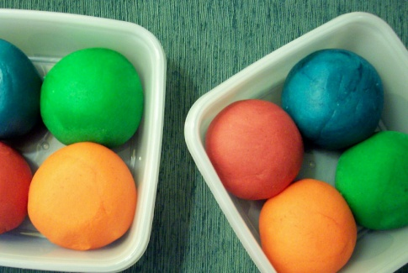
- Play Doh (store bought or homemade) – well, what list is complete without Play Doh? Rolled along your child’s hands and forearms for deep pressure input, used with teaching imitation, written in to develop letter awareness, shaped to develop shape awareness, scented with Kool Aid to provide olfactory sensory input, used as a stand for the abovementioned Wiz Kids cards – the possibilities are endless. Do you have a favourite recipe? Mine is posted in a previous blog post at www.fullspectrumlearning.ca.

Get some of your Christmas shopping done in your pajamas without having to leave home. Products above as well as many many more can be purchased online at www.discoverytoyslink.com/caseyburgess. Proceeds go to support local programs for children with Autism Spectrum Disorders.
If you are interested in a great kit of toys with or without deciding to sell or in a business opportunity with great product discounts, tax writeoffs, and a fun way to make extra income (or even start a new career), please visit www.discoverytoyslink.com/caseyburgess. Contact me for more information.

